Afirmative

I walk
You walk
He walks
She walks
It walks
We walk
You walk
They walk

Negative

I don’t walk
You don’t walk
He doesn’t walk
She doesn’t walk
It doesn’t walk
We don’t walk
You don’t walk
They don’t walk
Interrogative

Do I walk?
Do you walk?
Does he walk?
Does she walk?
Does it walk?
Do we walk?
Do you walk?
Do they walk?



Short answers

AffirmativeNegative

Yes, I / you / we / they doNo, I / you / we / they don’t
Yes, he / she / it doesNo, he / she / it doesn’t


Third person singular

We add –s to the verb to form the third person singular (he, she, it).
I drink – he drinks
I run – he runs

BUT
We add –es to verbs that end in –ss, -sh, -ch, -x, -o.
I watch – he watches

With verbs ending in consonant + y, we change the –y to –ies.
I cry – he cries
But with verbs ending in vowel + y, we just add –s as usual.
I play – he plays

We use the Present Simple:

for habits and actions that we do regularly:
He visits his friends every Sunday.
She goes to school by bus.

for general truths:
The sun rises in the East.

for permanent situations:
He lives in Athens.

Expressions used with the Present Simple
Frequency adverbs: always, usually, often, sometimes, rarely, never
(they are placed before the main verb)
Time expressions: every day / week / Friday…
on Mondays / Sundays…
at the weekend…
in the morning / afternoon…
in winter / spring…
once a day / week…



- Write the third person singular of the following verbs.

play ____________ go ____________

wash ____________ teach ____________
drive ____________ carry ____________
fly ____________ start ____________
help ____________ kiss ____________
watch ____________ tidy ____________
like ____________ enjoy ____________
cry ____________ mix ____________

B. Complete the sentences with the Present Simple of the verbs in brackets.
- Peter and his friends __________ to school by bus. (go)
- Elephants __________ leaves and grass. (eat)
- David's father __________ in a hospital. (work)
- The bank opens at 9.30 and __________ at 4.30. (close)
- Tom and Jim __________ football every day after school. (play)
- Mr Jones is a teacher. He __________ History. (teach)
- Our lessons __________ at 9.00 and __________ at 3.30. (start / finish)
- My pen friend __________ in Japan. (live)
- Mary and her brother __________ cartoons every Sunday morning. (watch)
- John __________ his room every day. (tidy)

C. Complete the blanks with the Present Simple of the verbs in the box.
go work ride deliver love jog rest fish walk


Mr Letty is a postman. He doesn't work in the post
office. He always works outside in the streets.
He __________ letters to all the people in the
neighbourhood every day. He doesn't __________
but he __________ his motorbike.
At the weekend, Mr Letty doesn't work.
He __________. He __________ the countryside,
so he always __________ to his country house with
his wife. Mr and Mrs Letty __________ in the river
and they __________ in the woods every weekend.

- Look at the pictures and write questions and answers, as in the example.


- play / the guitar / in the afternoon
Does he play the guitar in the aftenoon?
No he doesn’t play the guitar in the afternoon.
He plays the accordion.

- walk / after lunch
_________________________________________
_________________________________________
_________________________________________
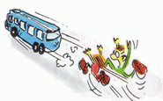
- ride / their / bicycles / to work / every day
_________________________________________
_________________________________________
_________________________________________

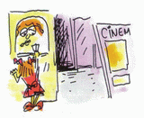
- listen / to the radio / every Sunday
_________________________________________
_________________________________________
_________________________________________
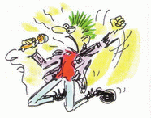
- clean / the house / on Mondays
_________________________________________
_________________________________________
_________________________________________
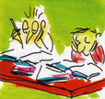
- watch / TV / after school
_________________________________________
_________________________________________
_________________________________________

- Complete the blanks with the negative or the interrogative form of the Present Simple of the verbs in brackets.
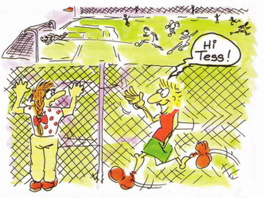
Mark: Hi, Tess! What are you doing?
Tess: I'm watching the football team.
Mark: Do you watch (watch) them every day?
Tess: No, I don't. They __________ (not play)
every day. They play four times a week.
Mark: __________ you __________ (have)
a favourite player?
Tess: No, I __________ (not have) a favourite player. Everyone on the team is
good.
Mark: __________ the attacker __________ (move) fast?
Tess: No, he __________ (not move) fast, but he's very clever. __________
you __________ (like) football, Mark?
Mark: No, I __________ (not like) it. I like basketball. It's a great sport.

