What does he do all day?

For daily routines use the present simple. Notice the adverbs of frequency in bold.
Fill in the correct form of the verb in the gaps provided.
Paragraph 1
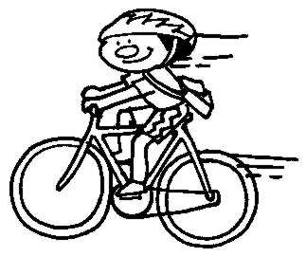
Mr. Busy always ______ ___ (get up) at 6:30. As soon as the alarm clock ____ ____ (go off) he ____ ___ ___(get out of) bed. He _____ (go) to the bath- room, _______(clean) his teeth, _____ (have) a shower and ________(brush) his hair. He never _____ (have) breakfast but he ____ (know) he should! At 7:15 he _______ (leave) the house. He always ________ (cycle) to work, even when it ____(be) raining. The journey _______ (take) him 20 minutes. He always _____(ride) along the river and _______(feed) the ducks at the bridge with some old bread. They ____ (be) always there waiting for him. He _______ (arrive) at work at 7:45. He ______ (make) some coffee and ___(be) sitting at his desk by 7:59. At 8:00, dead on the dot, he _______ ___ (turn on) his computer and ________ (start) to work. He _____ (has) a tea break at 10:00 until a quarter past. He _______ (drink) some tea and ____ (eat) an apple. Sometimes he __________ (make) some private telephone calls. Then he _________ (return) to his work.

Paragraph 2
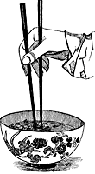
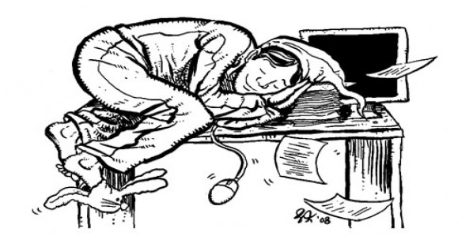
He ______ (work) hard until 12:30 when he ____ ____ (turn off) his computer and_____ (go) out of the office and into the High Street to meet some friends for lunch. They usually_____ (eat) at the local Chinese Restaurant. The food always _____ (taste) good, they ______ (serve) large portions and it ___ (be) quite cheap. The men ______(talk) about the weather (and other matters of interest) before paying and leaving.
Mr. Busy_________ return) to work at 1:30. He ____ (have) another break at 3:30, ______(make) another cup of coffee and sometimes ______ (put)his feet up on his desk and ________ (close) his eyes for twenty minutes. This he ______ (calls) his afternoon nap! After his nap he _______ (work) much better, he _____ (say)! He __________ (finish) work at 5:45, _______ __ (lock up) the office and _______ (cycle) back home. He ___ (be) always pleased to get home after a long day. He ______ (cook) himself a light meal and then _______(watch) television. On Thursdays he _____ (go) to evening classes. He is learning French. Mr Busy normally______ (go) to bed at 11:00. He _______ (like) to read in bed for a while before sleeping. He ____ ___ (drop off) at about 11:30. He hardly ever _______ __ (wake up) during the night. What a day that was!!

