not often eat ice cream | sometimes  be ill
get many  presents | like  spinach
play with a  teddy bear | 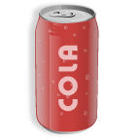  not drink a  lot of cola
go to  the seaside  every summer | not be good  at sports
not watch television  every day | be very good  at maths
be able to swim when 4 years old | have a very  nice  dog
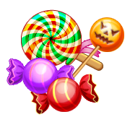  sometimes  buy sweets |   not drink  coffee
not write  Christmas cards | often have to do  a lot of  homework
not wear  glasses | sometimes help  my parents with the housework
listen to a  lot of stories | sometimes  fry sausages  with my friends
my dog sleep  in my room | often be afraid  of the dark
not know how to  play the guitar | 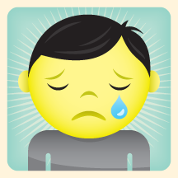  never be  unhappy
not know  Anne | love dolls  very much
always be  dressed as  a witch | 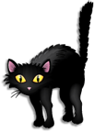  not be  afraid of cats
read a lot  of books | not like  the bus

